H.T No
Regulations:
A18

Sreenidhi Institute of Science and Technology
(An Autonomous Institution)
Code No: 7EC01 Date: 07-August-2024 (FN)

B.Tech I-Year II- Semester External Examination, August - 2024 (Supplementary)
DATA STRUCTURES (CSE and IT)

Time: 3 Hours Max.Marks:70

Note: a) No additional answer sheets will be provided.
b) All sub-parts of a question must be answered at one place only, otherwise it will not be valued.
c) Missing data can be assumed suitably.

Bloom's Cognitive Levels of Learning (BCLL)

Remember | L1 | Apply | L3 | Evaluate | L5
Understand | L2 | Analyze | L4 | Create | L6

Part - A Max.Marks:20
Answer all QUESTIONS

 |  | BCLL | CO(s) | Marks
1 | Define an ADT of Queue and list the applications of Queue. | L1 | CO1 | [2M]
2 | Write the node structure of Circular Linked List. | L1 | CO2 | [2M]
3 | Draw the Complete Undirected Graph on five vertices. | L3 | CO3 | [2M]
4 | Write a short note on the Bubble Sort. | L1 | CO4 | [2M]
5 | Define an Object. | L1 | CO5 | [2M]
6 | Distinguish between Multiple Inheritance and Multilevel Inheritance. | L2 | CO6 | [2M]
7 | What is postfix expression for the infix expression : a+b*c/d-e | L2 | CO1 | [2M]
8 | Is the following tree is AVL tree or not? If yes specify the reason.  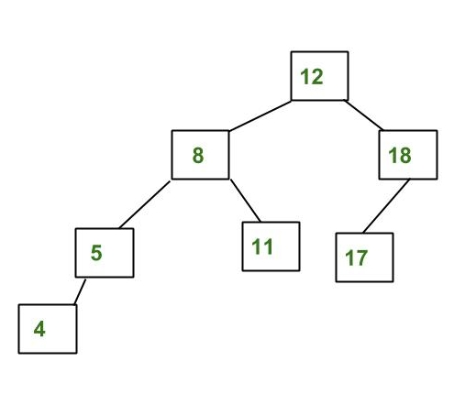 | L2 | CO3 | [2M]
9 | What are C++ access specifiers? | L1 | CO6 | [2M]
10 | Write a C program to perform linear search for finding a key value in a given list. | L2 | CO5 | [2M]
Part – B Max.Marks:50
ANSWER ANY FIVE QUESTIONS. EACH QUESTION CARRIES 10 MARKS.

 |  |  | BCLL | CO(s) | Marks
11. | a) | Write short notes on data structures. Differentiate linear and non linear data structures. | L4 | CO1 | [5M]
 | b) | Define stack. Why do we use stack? Write C code to perform operations on stacks. | L3 | CO1 | [5M]
12. | a) | Write a function to reverse a given singly linked list. | L3 | CO2 | [5M]
 | b) | Give the linked list implementation of stack. | L3 | CO2 | [5M]
13. | a) | What is the inorder, preorder and postorder traversals for the following binary tree?  .  Z  C  X  V  N  B  A  M | L3 | CO3 | [5M]
 | b) | Consider the graph given below  - Write the adjacency matrix of G1.  - Give Linked list representation of G1.  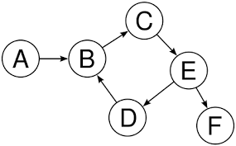  Fig. Graph G1 | L4 | CO3 | [5M]
14. | a) | Discuss the concept of bubble sort to sort the elements in ascending order. | L4 | CO4 | [5M]
 | b) | What is a max heap? How to insert elements into it? | L4 | CO4 | [5M]
15. | a) | Explain about Object Oriented programming concepts. | L2 | CO5 | [5M]
 | b) | Does C++ support Constructors? If so what are the types of constructors and describe each with an example. | L4 | CO5 | [5M]
16. | a) | List the operators that cannot be overloaded. | L2 | CO6 | [5M]
 | b) | Explain the use of this pointer in C++, give examples. | L3 | CO6 | [5M]
17. | a) | Given an empty Queue, after performing ENQUEUE(4), ENQUEUE(5), DEQUEUE(), ENQUEUE(3), DEQUEUE(), ENQUEUE(6), ENQUEUE(7). What are the Rear and front pointers of queue? | L2 | CO1 | [4M]
 | b) | What are the different types of Linked Lists? List any four applications of Linked Lists. | L3 | CO2 | [3M]
 | c) | Differentiate between DFS and BFS. | L4 | CO3 | [3M]
18. | a) | Write a C code for Insertion Sort using arrays. | L2 | CO4 | [4M]
 | b) | Write a short note on Destructors. | L1 | CO5 | [3M]
 | c) | With an example illustrate the purpose of Dynamic Memory Management Operators. | L4 | CO6 | [3M]
-- 00 -- 00 –

